# Factory Loader using INP3000 Programmer Board

The factory loader supports programming Talaria TWO using the INP3000 programmer board. The INP3000 Programmer Board supports programming via UART/SPI/SWD interface.

Following is a step-by-step process of how to use the factory loader using a INP3000 Programmer Board to load SSBL and a simple helloworld application.

1. Connect INP101x Talaria TWO module to the INP3000 programmer board. For more details regarding the INP3000 programmer board, please refer to UG_INP3000_Programmer_Board.pdf

Figure 2: Connecting INP3000 programmer board using UART

Figure 3: Connecting INP3000 programmer board using SPI

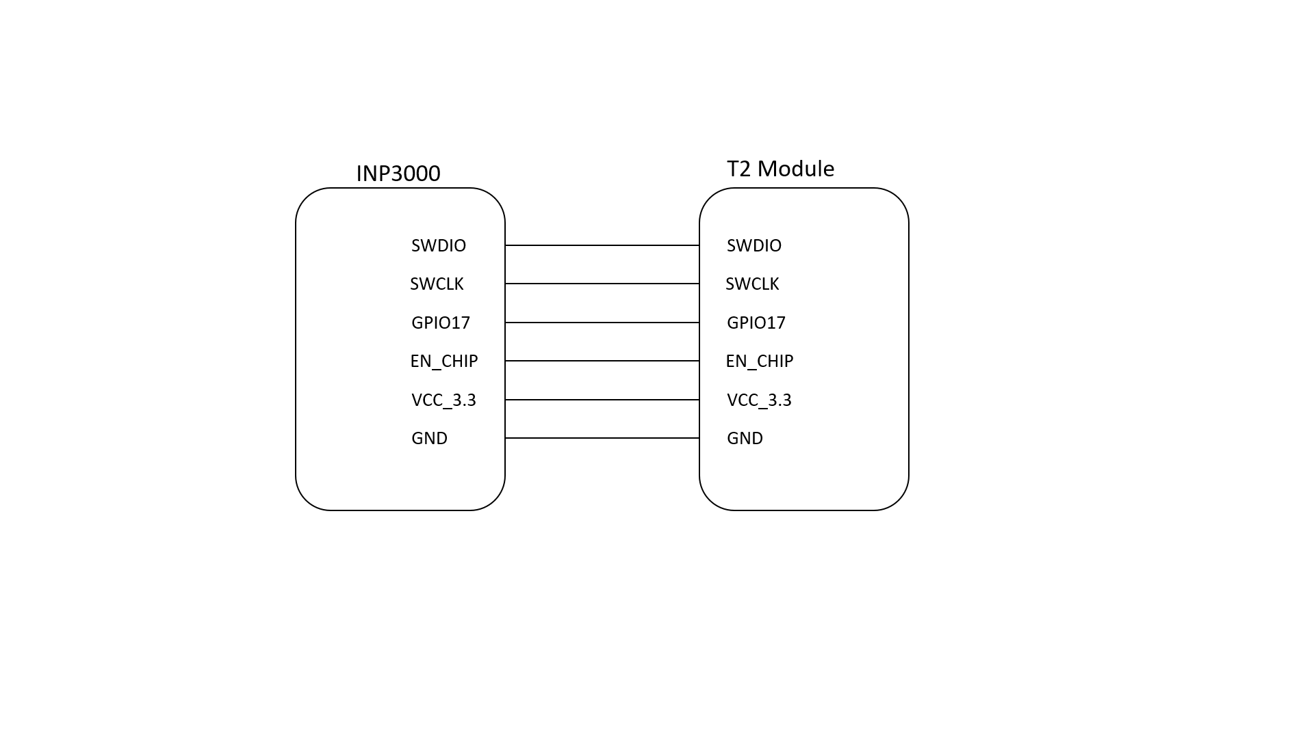

Figure 4: Connecting INP3000 programmer board using SWD

To program the Talaria TWO module using SWD, TAG connector available in the Programmer board package should be connected between the INP3000 V 4.0 SWD (J6) and Talaria TWO module SWD connector.

1. The following command is used to monitor the console output from Talaria TWO:

|  |
| --- |
| miniterm.py /dev/ttyUSB3 2457600 |

Figure 5: Factory loader application output

1. Connect the Talaria TWO module as described in UG_INP3000_Programmer_Board.pdf.
2. For UART interface

|  |
| --- |
| ./script/factory_loader.py ftdi_serial helloworld_config.json |

1. For SPI Interface

|  |
| --- |
| ./script/factory_loader.py ftdi_spi helloworld_config.json |

Reset Talaria TWO. It should now boot into SSBL and load the helloworld application as before.